NIGHT MAIL
Yes, this is a movie about a train and letters in the post, but it is about so much more. It is hoped that by the end of this brief resource, you will have a good idea of this 21-minute film’s extra significance, and a grasp of the pioneering work of the British Documentary Movement: the men and women who laid the ideological and practical foundations of ‘factual’ filmmaking in the decade before the outbreak of war in 1939. Come the Second World War, the lessons learnt in the 30’s would prove invaluable as these same young documentary producers and directors were called upon to pull off an extraordinary trick: creating propaganda that was ‘beguiling’ and ‘honest’ and ‘uplifting’ just at a time when the British population needed a sense of common purpose and shared identity.
But first – study this photograph of boys taken outside the gates of Lords Cricket Grounds on 9th July 1937. (Ian, it may difficult to include the actual image due to copyright issues – so here’s a link to the image for people to click on: Toffs and Toughs - Wikipedia The copy may need adjusting if the link is all we can provide.) It may be hard but try first to identify what is in the picture without interpreting it – this will ensure you have noted as much detail as possible (denotation). Next, attempt to interpret the image: considering the possible ‘meaning’ of the dress, body language and expressions of the two sets of boys. He presence of gates in the background should feature in your analysis. As part of this exercise, you could add word and thought bubbles suggesting what the five boys might be saying and thinking or you could come up with a title for the photograph as a whole.
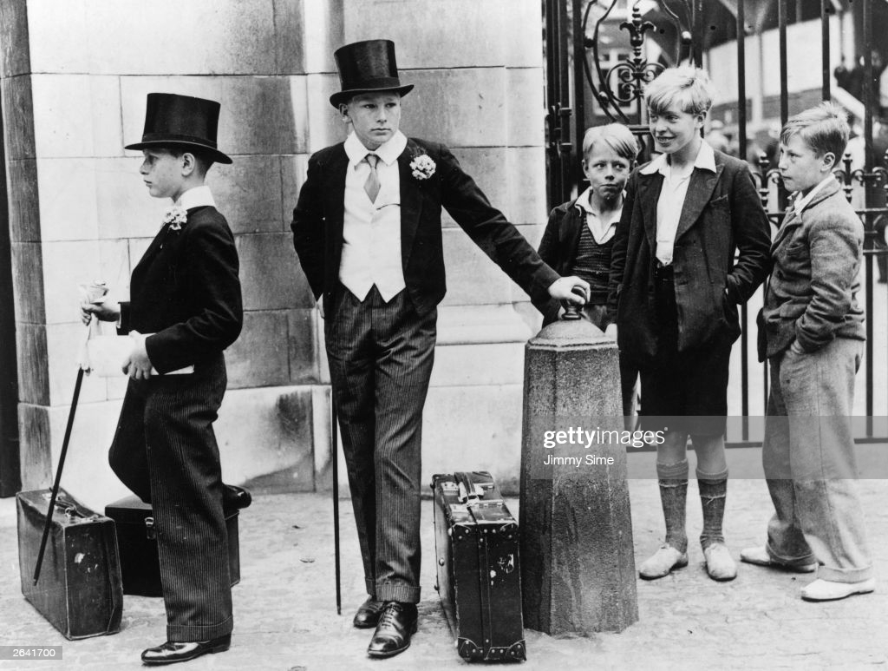
(To find out more research the Wikipedia entry about this famous photograph: does your attitude to it change in any way once you read about the very different lives these boys had ahead of them?)
This image crops up at the start of an extremely useful and informative film occasionally broadcast on BBC 4 called ‘Britain Through A Lens: The Documentary Film Mob’: BBC Four - Britain Through a Lens: The Documentary Film Mob. This image is used early on in the documentary to illustrate John Grierson’s perception that Britain of the 1930s in the grip of a terrible world-wide economic Depression was in danger of fatally fracturing along class lines. It was his contention that documentary films were a powerful means of healing those divisions. This is the context of Night Train. So, you see, the film is about a lot more than trains and letters. But first a bit about John Grierson and those he recruited to his mission to unify the country.
Activity 1: Night Mail Facts
The following 15 details about the origins of the GPO film unit and the making of Night Mail have been deliberately muddled and are in no sort of order. Your task is to organise these notes into a better order for writing an article about Night Mail. Share them out with classmates - ideally so there are two sets of you attempting this exercise with 15 people in each. Then try to create a line so that the information that should appear first is represented by students at the top of the line, and so on down the line through to the information, you feel, should appear lower-down in an article or account of the film’s making.
(You could add a stage so that you become more familiar with the material by giving out the facts to pairs of students and asking them to narrow down their bit into a shorter statement which they then have to tell others about within a time limit. And in addition, they must listen to the ‘facts’ they are being told in return.)
- John Grierson was insistent the film should end with the W H Auden poem because he felt without it the film told only half the story. In a film all about communication, it seemed wrong not to have something about the people receiving mail and how such communication touches all lives: “And none will hear the postman's knock/ Without a quickening of the heart, /For who can bear to feel himself forgotten?”
- To catch the sound of the ‘clickity-clicks’ that have to be counted before swinging the mail bag out of the train to be caught, the filmmakers had to commission the making a scaled-down model train to run on scaled-down tracks. This was because the true train made too much noise and the sound equipment could not capture the clicks.
- With the success of Night Mail, the GPO’s film unit suddenly found itself in demand and Grierson accepted commissions from other government agencies and private organisations such as the Coal Board, Ceylon Tea and the BBC. This was not approved of and Grierson was reprimanded: Government departments did not hire themselves out, he was told.
- While Basil Wright directed the aerial shots, Watt did all the filming inside the train and on location. Risks were taken: to get a shot of a leather mail pouch being whisked off into a trackside net, the main cameraman, Chick Fowle, had to hang out of the carriage, held by his legs, while the train travelled at a hundred miles an hour. Sometimes the nets burst and had that happened when Fowle was filming, he would have been killed. Watt recalled: “We hauled him in, his eyes streaming with water from the rush of the wind. Now it was over, I think we all realised what a foolhardy thing it was to have done.”
- One critic of the time wrote: “(Night Mail) is more exciting that any confected drama’. It opened in 600 cinemas.
- Responsibility for directing Night Mail was given to Basil Wright and Harry Watt. For Watt the experience was a difficult one. He was resistant to the idea of ending the film with the Auden poem accompanying the train’s journey through Scotland, and felt it was imposed on him.
- The Newman-Sinclair cameras used for most of the photography were cumbersome and awkward. Changing the lenses was fiddly and so rapid multi-shot filming was out. Also, the camera’s viewfinders showed the image being shot upside down so all involved hurt their necks trying to twist to see what was being shot the right way up.
- The famous letter-sorting section was not filmed on a train at all. Instead, it was a recreation of incidents witnessed by Basis Wright on numerous trips on the actual train. He turned what he had heard into a script which the real postal workers performed. The scenes were created on a set built in a studio in Blackheath, South East London – necessary because the sound equipment then had to be operated from a van parked outside: too bulky for actual location filming in the train carriage.
- According to poet Blake Morrison, Basil Wright felt hard done by when he received joint billing as director of the film with Harry Watt. He felt he had done the lion’s share of the work.
- Risks were taken making Night Mail; at one-point assistant cameraman Pat Jackson, sitting up on top of the coal holding a light reflector, almost lost his head as the train went under a bridge.
- Night Mail premiered on 4 February 1936 at the Cambridge Arts Theatre in Cambridge, England in a launch programme for the venue. Its general release gained critical praise and became a classic of its own kind, much imitated by adverts and modern film shorts.
- The shots of men sorting envelopes in the mail van were more easily accomplished, on a reconstructed set at the unit's studio in Blackheath. To simulate movement, pieces of string were dangled and jiggled about, and the men sorting the mail - real post office workers, not actors - swayed in accompaniment. (Source; Blake Morrison, BFI Night Mail DVD notes).
- Night Mail was made by the General Post Office (GPO) Film Unit. The GPO had swooped in 1933: taking on Grierson and his handpicked team of young filmmakers when they found their funds cut and their previous job making films promoting British Industry for the Empire Marketing Board at an end.
- Poet Blake Morrison tells how WH Auden was paid "starvation wages" of £3 a week when employed by the GPO film unit - less than he had been getting as a schoolteacher. As well as the poem at the end his other contribution was being in in charge of the second camera unit as they shot mail bags being moved at Broad Street station in London. Basil Wright thought it "one of the most beautifully organised shots in the film".
- The other formidable talent involved in Night Mail was the composer Benjamin Britten then only 22. Apparently, the director Harry Watt instructed him as follows: "Now I don't want any bloody highbrow stuff." Watt encouraged Britten to make the music jazzy. Britten ignored this, instead using a variety of items to create the train sounds including a compressed air cylinder, a snare drum and sandpaper.

Activity 2 – Representing Ordinary Working People And Their Contribution To Society
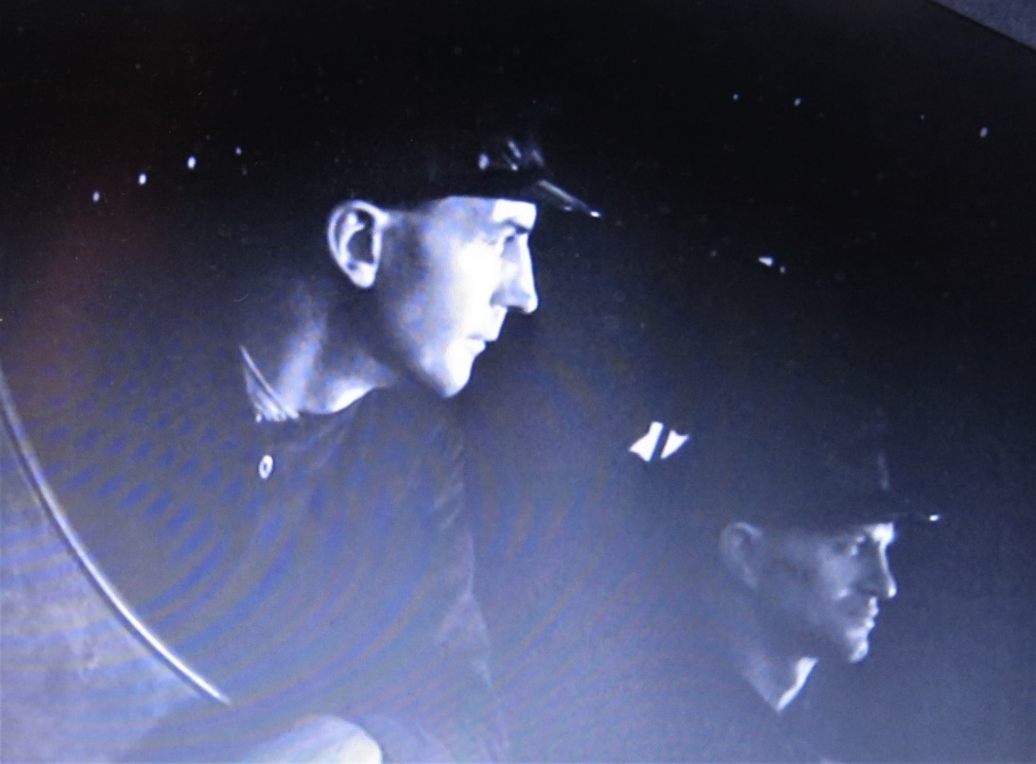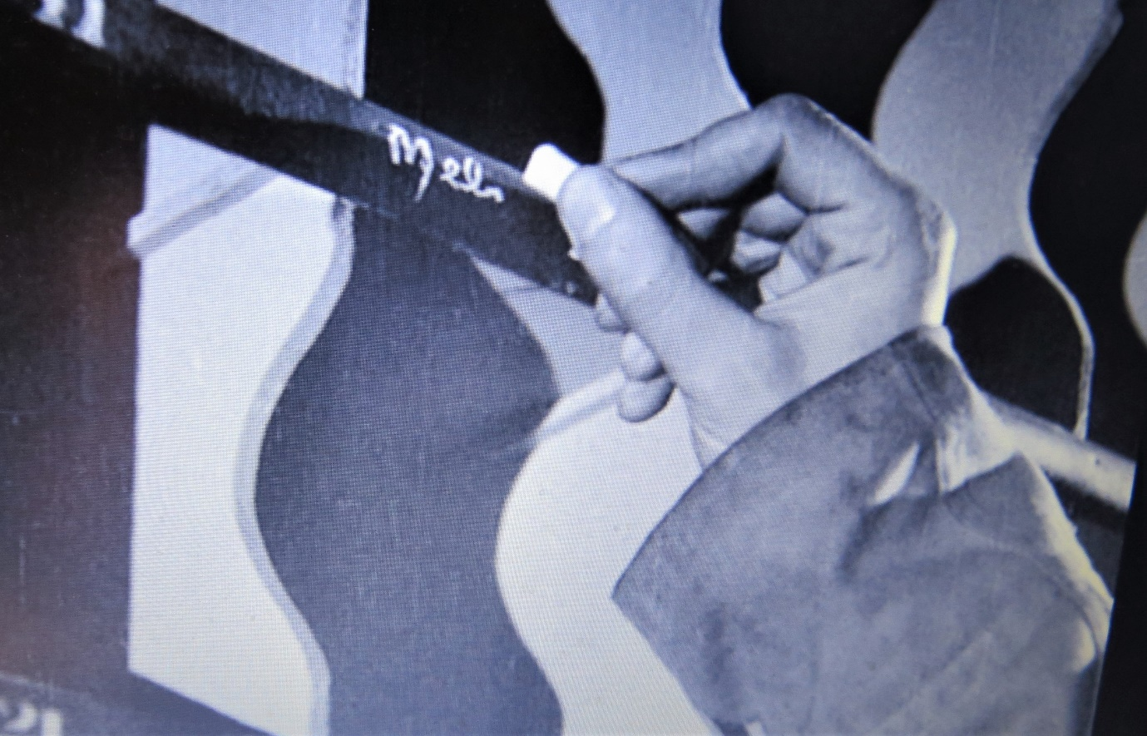

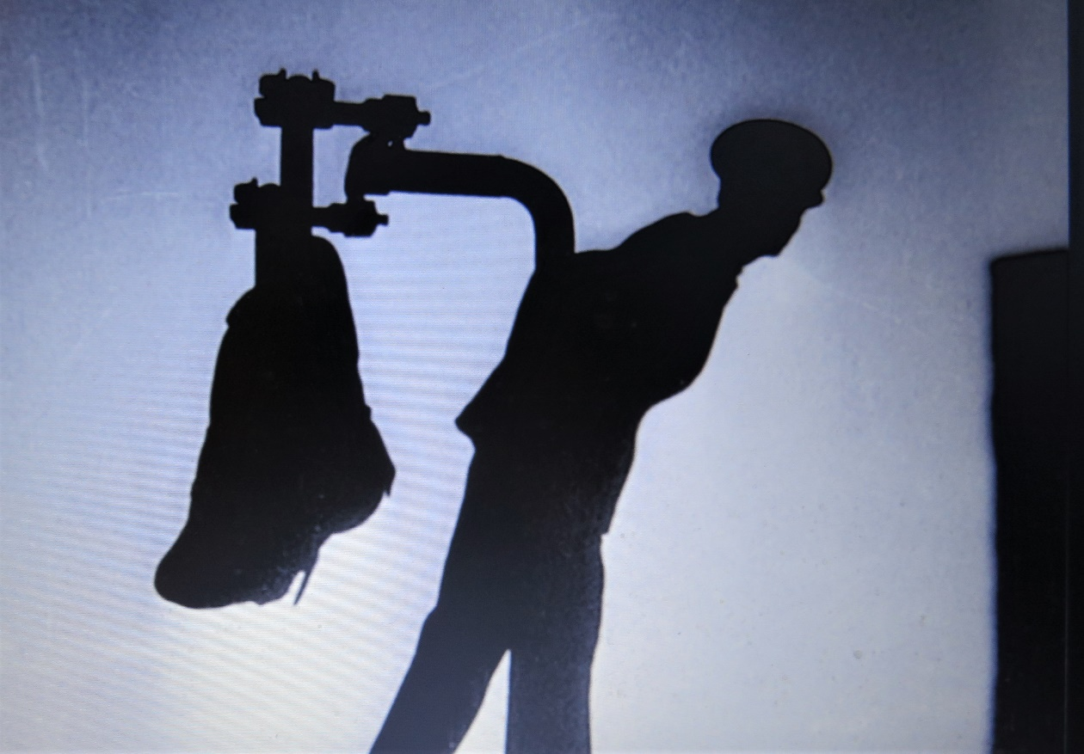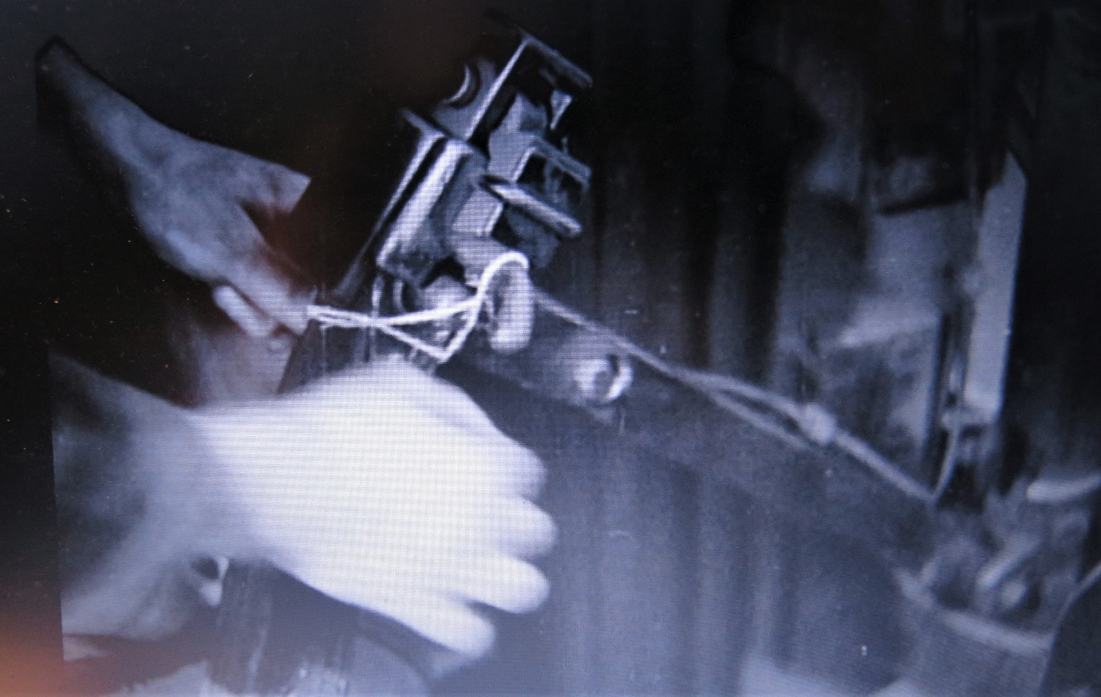

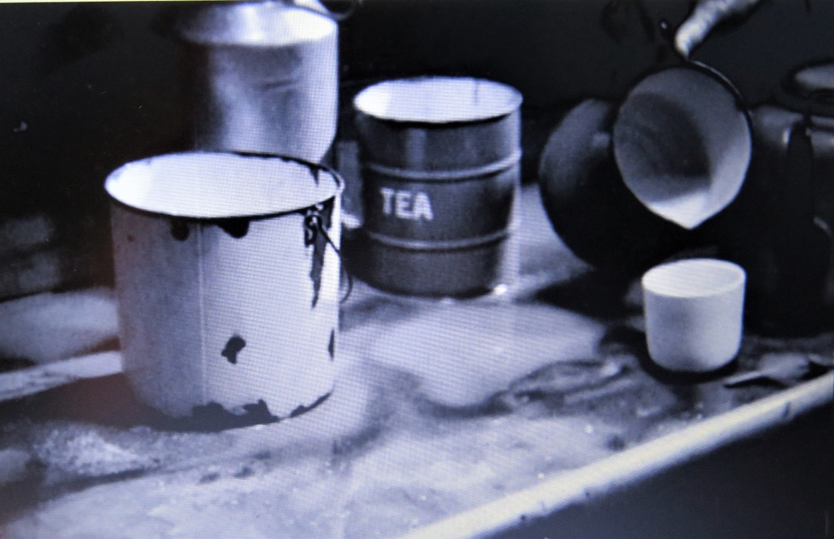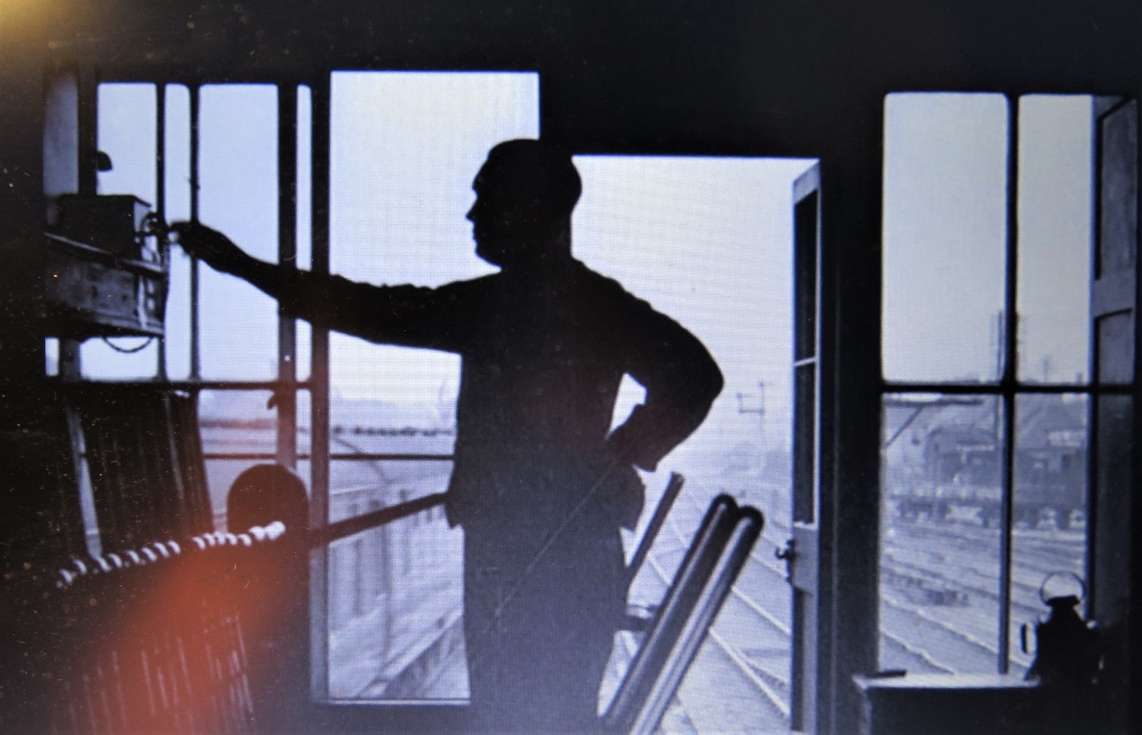

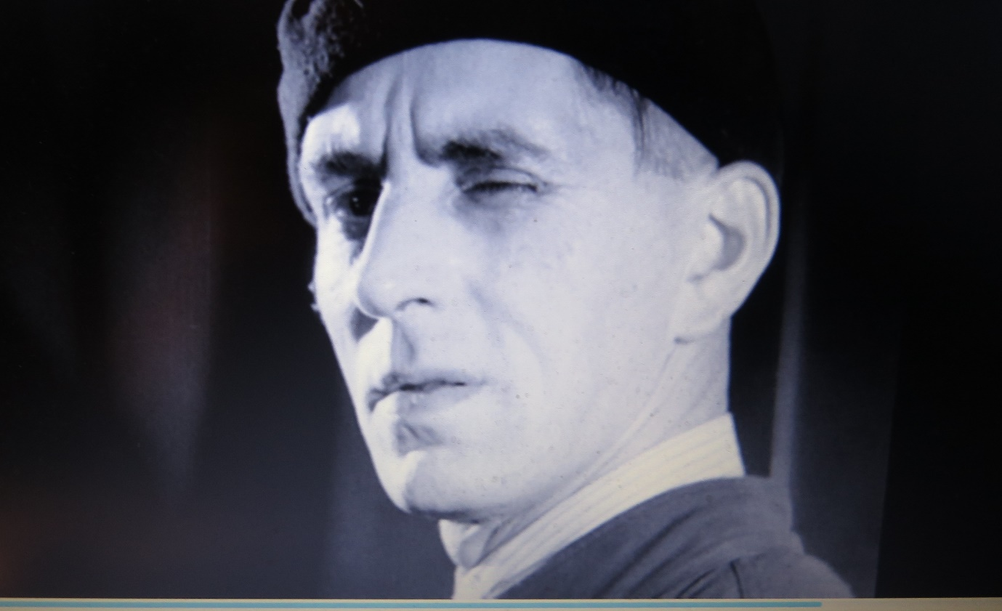
These seven shots from Night Mail are illustrative of the way the workers of the ‘Travelling Post Office’ and the ‘London, Midland and Scotland (LMS) Railway’ are depicted. Your task is to try to spot any patterns in the pictures and say how they individually suggest the humanity of the workers involved, their expertise and efficiency, their role as essential cogs in the giant technological feat of moving millions of letters and packets the length of Britain each day, their heroism, their dedication and their link to us, the audience.
As you watch Night Mail identify other sequences that, in your view, paint the workers in a positive, even flattering light and write down your impressions of them and their part in the monumental effort of moving, sorting and delivering the post in an age before email or social media.
Now read this and see if your reactions to the images above chime with the intentions of the film makers who created Night Mail.
One of the key issues with art forms that depict the world in realistic ways – however exaggerated or melodramatic - is the tendency for parts of those depictions to become fixed: so well-trodden that they seem automatic, usual, even unproblematic because they appear so ‘natural’. In this way such depictions become conventional. Conventions can be a part of the pleasure of film, so sitting down to watch a Western, it is reasonable to anticipate a shoot-out or wide-open desert landscapes. And of course, other film genres come with conventions attached: types and depictions of characters and settings that fit genre expectations and narratives that similarly run along broadly predictable lines. And sometimes these conventions can become cliches and sometimes they can become unhelpful distortions that end up dominating or influencing general attitudes to groups: feeding prejudices and encouraging discrimination or even demonisation.
It is in this context that Night Mail needs to be seen to be more fully understood. Grierson, it’s reported in a recent BBC film about the British Documentary Movement (Britain Through A Lens) – felt that Britain in the 1930s had ‘taken a wrong turn’ with ever increasing divisions between rich and poor threatening the stability of society.’ While he was a social reformer by nature, Grierson was not a revolutionary. What he hoped his films would reveal, Night Mail most prominently amongst them, was ‘how much people relied on one another – and especially the (often unobserved or ignored) hard labour of the working class.’
Grierson wanted his films to underline how genuinely interdependent Britain was and hoped his film would reveal this to audiences. ‘He told his disciples that the way to achieve this social purpose, all a documentary had to reveal was the truth about British life’ (Britain Through A Lens).
In terms of the post office there were specific factors surrounding the production:” Night Mail" originated from the desire to produce a film that would serve as the public face of a modern, trustworthy postal system, in addition to boosting the low morale of postal workers at the time. The postal sector had seen an increase in profits in the late 1920s, but by 1936 wages had fallen 3% for most GPO employees. The Trade Disputes and Trade Unions Act 1927 had seriously curtailed postal union power, and the Great Depression fostered a general mood of pessimism. The liberal-minded Watt, Wright, Grierson, and other GPO film unit members, therefore, wanted Night Mail to focus not only on the efficiency of the postal system but its reliance on its honest and industrious employees” (Source: Night Mail - Wikipedia)
Here are two further quotations that should greatly enrich your understanding of the philosophy behind the making of the film:
“We were putting the British working man, the backbone of the country, onto the screen. Before that he was the comic relief in ghastly British films – <films> that always started with the butler and the maid and then the funny gardener and the funny taxi-driver. We knocked all that down.” (Basil Wright – interviewed for the documentary ‘Britain Through A Lens’ BBC Four - Britain Through a Lens: The Documentary Film Mob)
“Can we imagine a world without letters. Does anyone appreciate the postman? We take him for granted like the milkman, the coalman, the engine-driver, the whole lot of them. We must acknowledge them; pay them respect and gratitude …. that is what documentary is all about.” (John Grierson quoted in the documentary ‘Britain Through A Lens’ BBC Four - Britain Through a Lens: The Documentary Film Mob)
It is your broad task on viewing Night Mail is to decide whether or not you feel the film lives up to these objectives.
Activity 3: Mini-Dramas
It has been said of one of John Grierson’s earliest documentaries (‘Drifters’ 1929) about the herring fishermen of Great Yarmouth that, unlike the usual fare at the cinema, this film ‘had no handsome hero, no love story and no thrilling plot.’ Instead, it was a tale of ordinary workers doing their (admittedly) often hazardous jobs. The same list of absent elements could easily apply to the ‘cast’ and narrative of Night Mail, and yet….
It is not as if Night Mail is without its occasional heroes and its minidramas. As you watch the film see if there are any individuals amongst the workers that stand out. Night Mail’s success at breathing real life into people who sometimes only feature for a few seconds is one of its great achievements.
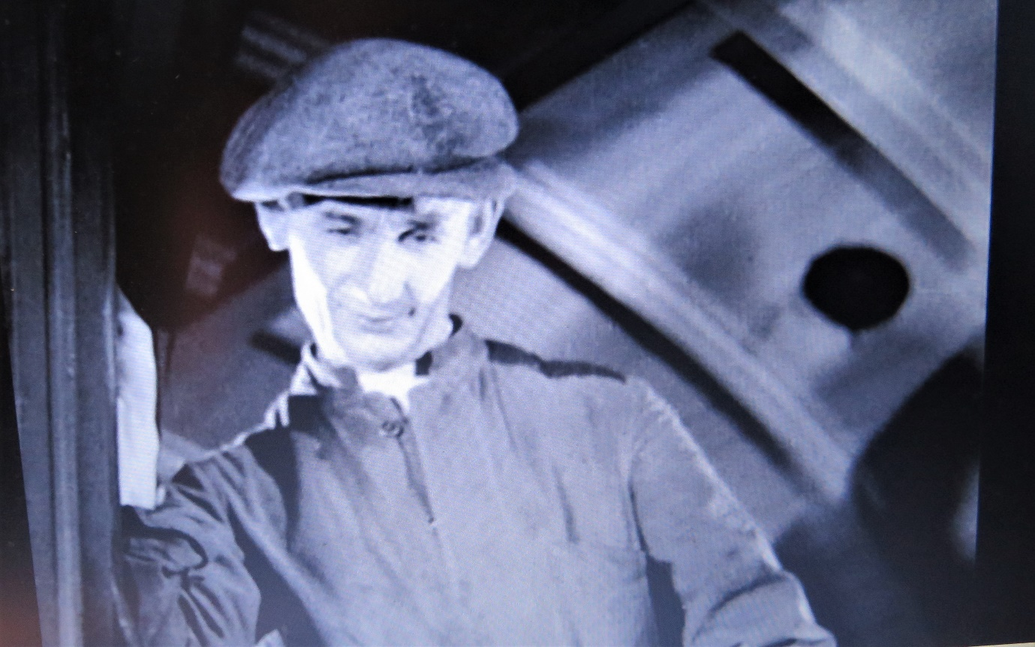
Here is a low angle shot of one of the ‘heroes’ of Night Mail. He is wonderingly/admiringly studying the satchel of mail that has been dangled from the side of the train awaiting the apparatus that will snatch it away. He is the novice of the team – learning the ropes and in various interactions with other more experienced workers and a supervisor, we come to understand his nervousness and also how the mail bags are prepared for final dispatch from the side of the train as it rushes by at 70 miles-an-hour. Two birds hit with one stone!
Your task is to identify the other mini-narrative arcs that occur in Night Mail and how ‘drama’ is created through a combination of editing and sound and whether or not any particular individuals emerge at any of these moments of tension. Look out for the drama of the workers on the line; and the late train from Holyhead, in particular. Also consider the sequence where a newspaper is dropped from the train for the farm-worker. What does this do to further the aims of the film mentioned at length in the previous task? (The soundtrack is a bit hard to decipher, but it is likely the farmer calls the cricket result to his mate.) (04.56)
Also look out for the following brief moments of dialogue and try to explain what they contribute to the overall effect of the film. Remember while much of the dialogue – especially in the sorting carriage scenes was scripted, it was all based on conversations Basil Wright heard during the course of dozens of journeys up and down the LMS line:
- People in the passenger train that is halted for the Night Mail slumbering in their seats or enquiring about the delay (04.08)
- The Bletchley postmen complaining about the heavy bags and joking about Bert’s coupon night. (06.00) (The coupon refers to the ‘Pools’ – a kind of weekly gambling game in which participants guess the football results for the following weekend’s games.)
- The farewells in the café as the Scottish crew takes over from the English team in Crewe, and the banter as the two groups of men pass each other – some off home, the others just starting their shift (9.49)
- The banter on the platform as the postmen try to load the Night Mail with the late arrived bags of post from Holyhead: ‘What does he think we’re doing: playing push ha’penny.’ (11.21-22) (A pub game involving shoving a small coin.)
- The issue of the misdirected Dulgarreth letter and the sorter’s reaction to the supervisor’s ‘It’s a change for you…’ (15.18)
- The ‘Take it away, Sunnyboy!’/’Righto handsome!’ exchange. (16.54-55)
There are others.
Study the editing and soundtrack in detail between 17.08 and 18.54 during which the mailbag is prepared, hoisted and finally it is detached while new mailbags with mail for sorting for Scotland and the North come aboard. It is a masterwork of editing and sound editing designed to create excitement and tension. It also creates a fascinating link between the individuals in the sorting carriage and the mechanisms and the processes involved. If you can, stop and start the film at each cut and draw a simple sketch of the scene and in so doing create a storyboard of the sequence. As said, it is a great example of editing and one that will stand you in good stead when it comes to being sensitive to the editing in other films. Do you agree with the statement made in the BBC film about the Documentary Film Movement (already much mentioned) that one of the great successes of Night Mail was to give audiences a sense of what it was like to be actually there, in the sorting carriage, rubbing shoulders with the postal workers, ‘as the action takes place’?
Activity 4: Epic Landscapes
As well as providing rounded portraits of ordinary working men of the Night Mail, the film continued the work of previous documentaries made by Grierson’s team in representing Britain’s industrial landscapes in a positive light. Here is just one such shot from the film and your task is to describe the impact it has on you. Attempt to use it as a prompt for a piece of creative writing as if you were producing the script for this moment in the film. To experiment with the power of such a script which acts like the caption to a still photograph, attempt to write a positive and then a negative account to go with this image.
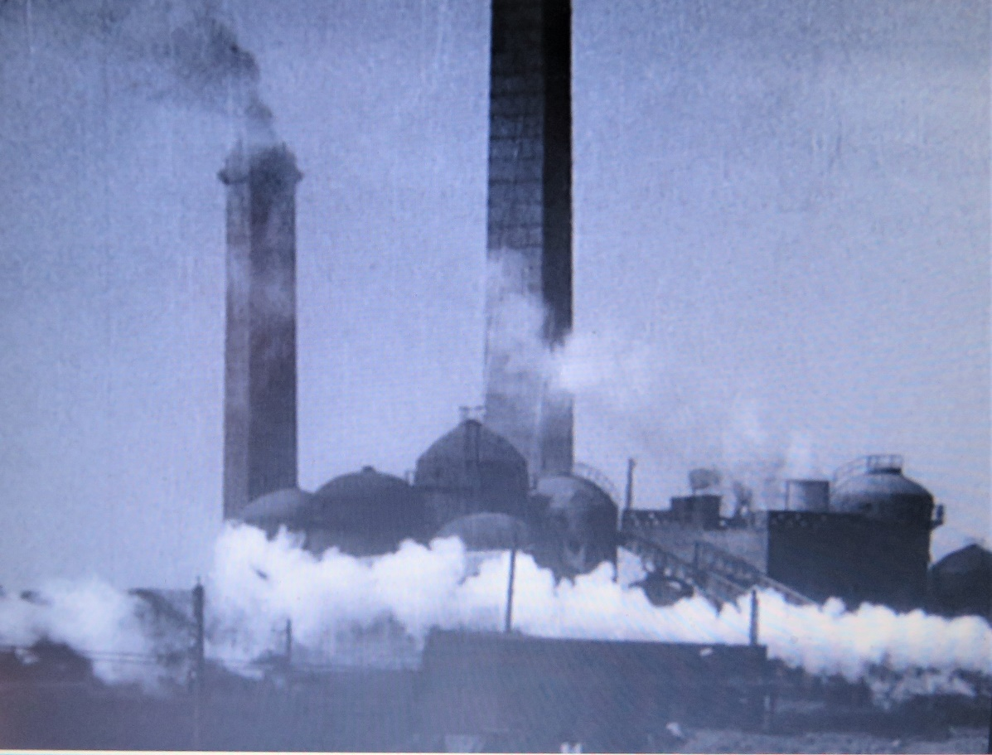
Montage and Poetry
Look back at the ‘Facts’ exercise earlier in this resource: there you will find background details explaining the origins of the three-minute sequence that takes us from the moment the train crosses the border into Scotland and finally arrives in Aberdeen. It is quite unlike the rest of the film and because of its combination of music, poetry and montage, it is the major reason why Night Mail has survived as such a testament to the Documentary Film Movement.
That term ‘montage’ needs some unpacking – and one of the most comprehensive discussions of this editing technique can be found at: What is a Montage? Definition, Examples & 6 Ways to Use Them (studiobinder.com). According to the site’s writer Kyle Deguzman, montage can be used to achieve any or all of the following: speed up time; add comedic effect; build character quickly; establish the surrounding context of a story by providing a series of snapshots; tell multiple stories in parallel and, perhaps the trickiest, create meanings by placing images or sequences next to each other. Deguzman’s site discusses the legacy of the Russian filmmaker Lev Kulesho: The Kuleshov Effect Explained (and How Spielberg Subverts it) (studiobinder.com). It is essential for your film general knowledge to follow that link and watch the way Kuleshov demonstrated how emotions can be manipulated through the juxtaposition of different images thanks to our human bias towards creating narratives and seeing patterns.
With this under your belt, now re-watch the final three minutes of Night-Mail without the sound on and see how, even without the music and the poetry, you will automatically start to create links and connections and a narrative from what are quite a jumble of images. Of course, the soundtrack sounds (both words and music) are crucial to fully grasping what is going on, but it was the images that dominated the sequence’s construction and they perform a lot of the ‘heavy-lifting’ when it comes to creating meaning.
Auden
This is an extract from an essay written by the poet Blake Morrison which was provided with the BFI DVD of Night Mail and a version of which, helpfully, also appeared in the Guardian (Blake Morrison marvels at Night Mail | Books | The Guardian). He is speaking of W H Auden and his time working with the GPO film unit on the film: “Those brief six months may have left their mark on him in deeper ways, however. A striking aspect of Night Mail is the way it cuts from the dramatic onward rush of the Postal Special to shots of people and landscapes that have little to do with its journey - a farmer leading a horse, for example, or a black dog running in a field. This contrast between the march of history on the one hand and ordinary life persisting untouched on the other is central to the poetry Auden was writing a few years later: "Musée des Beaux Arts", for example, with its glimpse of "some untidy spot/Where the dogs go on with their doggy life and the torturer's horse/Scratches its innocent behind on a tree". Or "The Fall of Rome", which ends with an image of a world unaffected by politics, war and imperialism.”
Your task here is to look up and read those two poems (in bold) so that you can fully understand the point Morrison is making. It is also important you read the poem Night Mail itself. What is your reaction to it? Which of its images do you find most moving/compelling/memorable? How successful do you feel it is as the coda to the documentary: making the link between the train and its processes and the point of the whole enterprize: bringing news to the general population?

Night Mail – W H Auden
This is the night mail crossing the Border,
Bringing the cheque and the postal order,
Letters for the rich, letters for the poor,
The shop at the corner, the girl next door.
Pulling up Beattock, a steady climb:
The gradient's against her, but she's on time.
Past cotton-grass and moorland boulder
Shovelling white steam over her shoulder,
Snorting noisily as she passes
Silent miles of wind-bent grasses.
Birds turn their heads as she approaches,
Stare from bushes at her blank-faced coaches.
Sheep-dogs cannot turn her course;
They slumber on with paws across.
In the farm she passes no one wakes,
But a jug in a bedroom gently shakes.
Dawn freshens, Her climb is done.
Down towards Glasgow she descends,
Towards the steam tugs yelping down a glade of cranes
Towards the fields of apparatus, the furnaces
Set on the dark plain like gigantic chessmen.
All Scotland waits for her:
In dark glens, beside pale-green lochs
Men long for news.
Letters of thanks, letters from banks,
Letters of joy from girl and boy,
Receipted bills and invitations
To inspect new stock or to visit relations,
And applications for situations,
And timid lovers' declarations,
And gossip, gossip from all the nations,
News circumstantial, news financial,
Letters with holiday snaps to enlarge in,
Letters with faces scrawled on the margin,
Letters from uncles, cousins, and aunts,
Letters to Scotland from the South of France,
Letters of condolence to Highlands and Lowlands
Written on paper of every hue,
The pink, the violet, the white and the blue,
The chatty, the catty, the boring, the adoring,
The cold and official and the heart's outpouring,
Clever, stupid, short and long,
The typed and the printed and the spelt all wrong.
Thousands are still asleep,
Dreaming of terrifying monsters
Or of friendly tea beside the band in Cranston's or Crawford's:
Asleep in working Glasgow, asleep in well-set Edinburgh,
Asleep in granite Aberdeen,
They continue their dreams,
But shall wake soon and hope for letters,
And none will hear the postman's knock
Without a quickening of the heart,
For who can bear to feel himself forgotten?
(Words to the poem Night Mail by WH Auden (oatridge.co.uk))

